FAST FAL19/1×34D Red Dot Thermal Imaging Scope
Operating Manual
V1.3
InfiRay Technologies Co., Ltd.
Specifications
 | Model | Fast FAL19/1×34D
Direct View Optics | Magnification | 1×
 | Display | High luminance OLED
 | Window Size | 34mm×25mm
 | Eye Relief | 90mm
Thermal Channel | Resolution, pixels | 384×288/12μm
 | Objective Lens, mm | f19 /F1.0
 | Recognition Distance | 450m
 | NETD | ≤40mk
 | Frame Rate, Hz | 50Hz
 | FOV | 13.8°x10.4°
 | Focus Range | 5m-∞
 | Digital Zoom | 1×、2×
 | Mode | Red dot/Full/Fusion/Outline
 | Polarity | Green hot/Black hot
Electrical | Battery Type | 2×CR123
 | Battery Life | Thermal mode>4h  Red dot mode>65h
 | Electrical Interface | 5V (USB-C)
Mechanical | Interface | Picatinny
 | Weight (with battery) | <660g
 | Dimension | 175mm×63mm×104mm
Environmental | Operating Temperature | -40℃~+50℃
 | Storage Temperature | -50℃~+60℃
 | IP Rating | IP67

*The actual service time depends on the use frequency of the product;
Improvements may be made to the design and software of this product to enhance its features without prior notice;
You can download this Operating Manual at our official website: www.infirayoutdoor.com

I. Package Contents
- Fast red dot thermal imaging scope
- Portable bag
- USB-C cable
- Lens cleaning cloth
- Recoil-absorbing mount
- Support screws: M3×6 cross recessed screw (2 pcs.)
- Wrench: M3 L-shaped cross wrench
- Product manual

II. Description
The Fast red dot thermal imaging scope is a high-end product provided with fast red dot scope and infrared thermal scope. It combines detection chips with ultra-high sensitivity to restore the color and details of infrared images during daytime and night. It also has an eyesight system with ultra large FOV and fast targeting red dot reticle, as well as rich functions. It can be widely used for hunting and observation under complex or harsh conditions, and also can be used in military and police law enforcement occasions to effectively improve the duty efficiency.

III. Product Features
- 1× red dot, visual magnification of 1, which gives the user a three-dimensional visual effect when observing with both eyes;
- All-weather application day and night, combining the traditional red dot scope with the infrared scope;
- Multiple image modes (single red dot/highlight mode/outline mode), including special fusion modes;
- Multi-layer coating technology, which can effectively reduce the interference of stray light during use;
- IP67, dust-resistant and waterproof;
- Impact resistance up to 1,200g, applicable to gun types below 7.62 mm.

IV. Device Composition

- P button
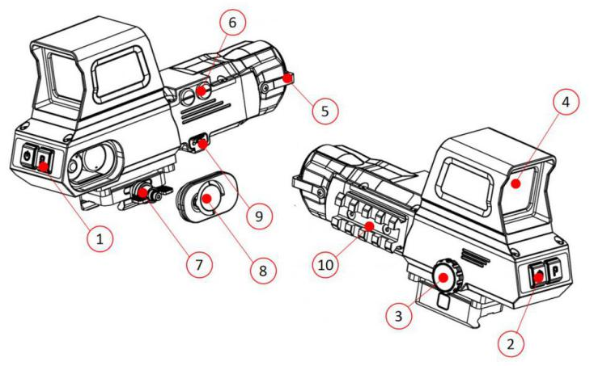
2. Power button
3. Rotary function button
4. Window
5. Objective lens cover
6. Red dot adjusting screw
7. Recoil-absorbing mount
8. Battery compartment waterproof cover
9. USB C interface
10. Picatinny

V. Button Operations
No. | Button | Current Mode | Press | Press and Hold
1 | Power button | Powered off | ---- | Start up the device
 |  | Home screen | Digital zoom | Shutdown
 |  | Menu screen | Return to the home screen | Shutdown
2 | P button | Home screen | Image calibration | Switch the image mode
3 | Rotary function button | Powered off | ---- | Turn on/off the red dot
 |  | Home screen | Press: to enter the menu screen Rotate: to change the brightness of the red dot
 |  | Menu screen | Press: to confirm  Rotate: to change an option

VI. Battery Charging
The Fast infrared thermal imaging scope adopts two CR123/CR123A batteries for power supply, with the normal power supply time up to 4 hours. The battery should be fully charged before first use.
Battery Replacement and Installation
- Rotate the battery cover handle clockwise;
- Hold the handle and pull it out;
- Install two CR123 batteries into the battery compartment according to the positive and negative poles;
- Install the battery cover back in the correct direction;
- Rotate the battery cover handle anticlockwise, lock the battery compartment cover, and fix it to the corresponding position.

Note: 1. When the USB-C cable is used for power supply, the USB-C cable will be preferred for power supply, and the battery will be stopped.
2. The product supports 3V and 3.7V batteries. To ensure the correct display of the power level, please select the correct battery voltage in the menu.

Safety Precautions
- When charging, please use the 5V2A power adapter compatible with the device. Using any other type of adapter may cause irreversible damage to the battery or the adapter itself;
- If the device is not in use for a long time, the battery shall be taken out of the device and stored in a dry place.
- Do not charge the device immediately after it is moved to a warm environment from a cold environment. Wait for 30 to 40 minutes for preheating.
- If the charger is modified or damaged, do not use it;
- The device shall be used at the temperature of 0℃~+40℃, under which the battery is of the best performance, or else the battery activity will be decreased significantly.
- When charging a lithium-ion battery, please do not leave the battery unattended;
- Do not connect the battery to the power supply for more than 24 hours after it is already fully charged;
- The device is equipped with a short circuit protection system, but operations or conditions that may lead to a short circuit should be avoided.
- The recommended operating temperature for the device is from -20°C to +40°C. If the product is used beyond this temperature range, it can work normally, but the battery life may be shortened.
- When the device is used under sub-zero temperature, the battery capacity drops. This is normal and does not indicate a defect.

VII. External Power Supply
The Fast infrared thermal imaging scope supports external power supplies such as phone chargers (5V2A) or a computer USB interface.
- Connect the external power supply to the USB-C cable (10) of the Fast infrared thermal imaging scope;
- Then, the device automatically switches to the external power supply;
- When the external power is turned off or disconnected, the device will switch to the lithium-ion battery for the power supply.

VIII. Installation and Usage
Fixed installation
WARNING! The lens of the product must not be pointed at any sources of intense radiation energy, such as laser-emitting devices or the sun. This may damage the electronic components in the device. Damage caused by failure to comply with the operating guidelines is not covered under warranty.
To ensure shooting accuracy, please fix the Fast at a proper picatinny rail position on the equipment.
- Fixing Fast requires the use of recoil-absorbing mount provided in the packaging, as follows:
- Find the notch of the recoil-absorbing mount and align it with the corresponding notch at the bottom of the product
- Use the support screw (M3×6 cross recessed countersunk head screw) and fixing wrench (L-shaped M3 cross wrench) attached to the package to fix the recoil-absorbing mount at the bottom of the device
- During installation, you can adjust the installation position of the Fast infrared thermal imaging scope according to the comfortable distance between your eyes and the device (eye relief). If you fail to follow this suggestion, the eyesight part may hurt the shooter during the shooting.
- It is recommended to use a torque wrench to tighten the screws of the installation clamps, so as to avoid damaging the support locking mechanism due to being over-tightened, and the recommended torque shall not exceed 2.5Nm;
- When the scope is used for shooting or hunting, please carry out the zeroing operation first according to the instructions as specified in" Chapter IX Zeroing" in this manual;
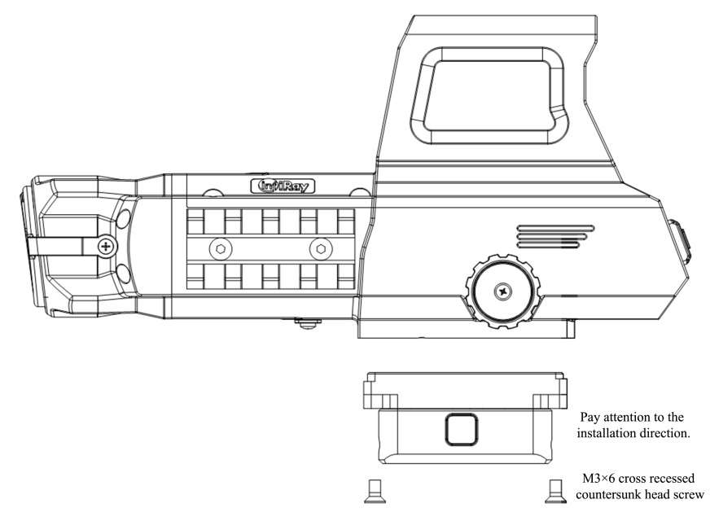
Power on and Settings
- Open the lens cap (5); if the outdoor sunlight is relatively strong, pay attention not to face the infrared lens directly to the sun to avoid burns;
- Press and hold the power button (2) for 3s to power on the device;
- To set the image mode: On the home screen, press and hold the P button (1) green hot, black hot, outline (breathing effect), and fusion in sequence, and the icon on the top status bar is updated in real time;
- To open the aiming point: On the home screen, press and hold the rotary function button (3), and a bright spot appears in the center of the screen, then rotate the encoder to adjust the color and brightness of the aiming point on the screen;
- To set the display brightness and image contrast: Press the rotary function button (3) to enter the main menu to set the display brightness and image contrast (refer to "Main Menu Functions" for details);
- After use, press and hold the power button (2) for 3 seconds and a shutdown countdown is displayed. Rotate the encoder, select "√" and press the encoder again, then the display turns black and the device is powered off. When the device is powering off and saving data, do not disconnect it from the power source. Otherwise, the data cannot be saved.
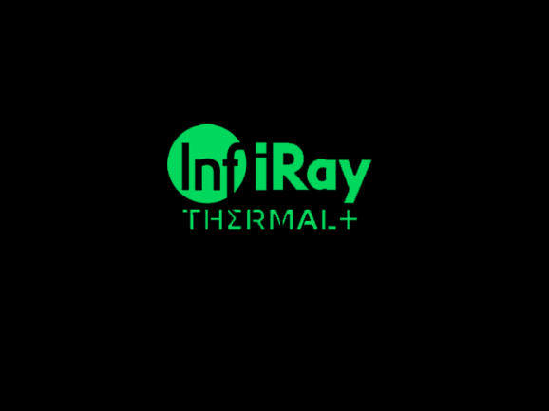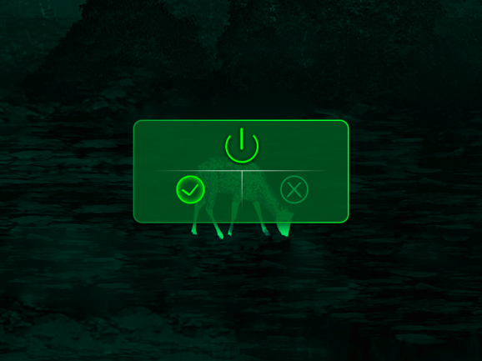

IX. Zeroing
The Fast infrared thermal imaging scope series adopts the "frozen" method for zeroing. It is recommended to carry out the zeroing operation within the range of operating temperature of the scope.
- Fix the scope on the weapon with a support;
- Select a target of a distance of 100m;
- Adjust the scope according to the operating instructions as described in Chapter VIII Power On and Settings;
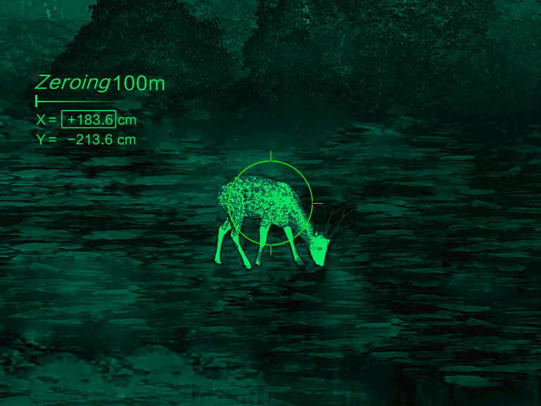
- To select Zeroing: Press and hold the rotary function button (3) to enter the advanced menu interface and select the zeroing option, and press the rotary function button (3) to enter the submenu of the zeroing function;
- Enter the zeroing screen, and the coordinate position (X axis and Y axis) of the reticle are on the upper left corner of the screen;
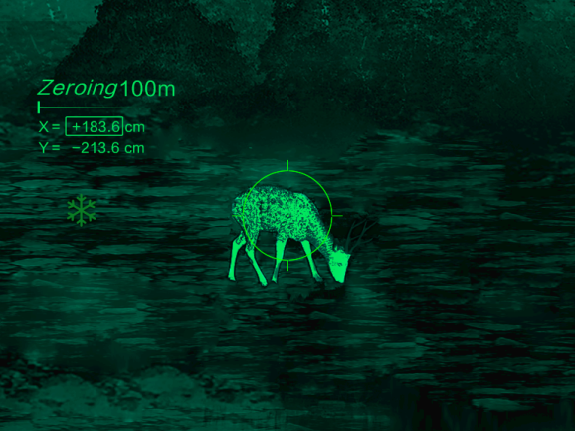
- Shoot at the target;
- Observe the position of the actual point of impact, and now the screen is frozen and a frozen snow icon appears on the left of the screen. Assume that the red mark × in the figure on the right is the position of the point of impact (This mark is only for illustration. It should actually be a bullet hole);
- Turn the rotary function button (3) to move the reticle, rotate clockwise to move the cursor left or down, and rotate anticlockwise to move the cursor right or up;
- Turn the rotary function button (3) to switch between the X axis and Y axis, and the position of the bright cursor indicates the currently selected item, and the icon turns blue;
- After moving the reticle, a little dot appears on the display, indicating the position of the reticle before moving;
- After moving the reticle to the actual point of impact, press the rotary encoder to exit moving, and then press the power button to save the current reticle position and return to the main screen of the advanced menu;
- Repeat aiming and shooting, until the position of the point of impact is consistent with that of the aiming point.

X. Digital Zoom
The Fast infrared thermal imaging scope can enlarge an image to 1× or 2×.
- On the home screen of infrared mode, press the power button (2) to zoom the image;
- The magnification status is displayed at the status bar of the display area in real time.
XI. Status Bar
The status bar is located at the top of the image interface and displays the information related to the current operating status of the device. From left to right, there are:
- Current image mode (green hot, black hot, outline (breathing effect), fusion)
- Current analog video switch
- Calibration mode (manual calibration, automatic calibration, background calibration)
- Digital zoom
- Battery level
- Battery type
Note: When the inside of the icon is in green, it means that the power is higher than 20%, indicating that the battery power is sufficient. When the icon flashes, it means that the battery power is low, please charge it in time.

XII. Shortcut Menu
The shortcut menu can be used for a quick setup of the basic settings of some common functions, including image mode, image contrast, display brightness, reticle brightness, advanced menu, and exit. Press the rotary function button (3) to enter the shortcut menu, then press the button to save, and press the power button to return to the home screen.
- On the home screen, press the rotary function button (3) to go to the shortcut menu screen;
- Rotate the rotary function button (3) to switch between the following function options, and the icon background of the selected option is highlighted:
    - Image mode: Rotate the rotary function button (3) to select this option, and then press the rotary function button (3) to adjust between the following image modes: green hot, black hot, outline (breathing effect), and fusion;
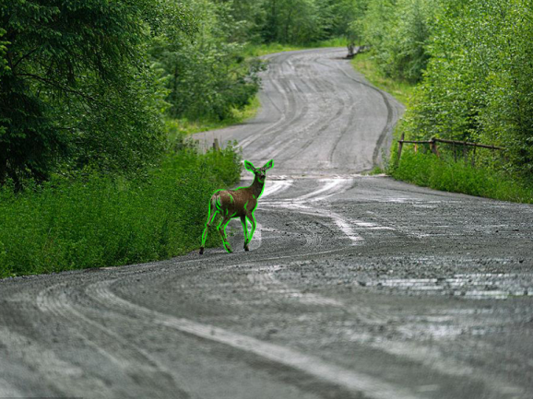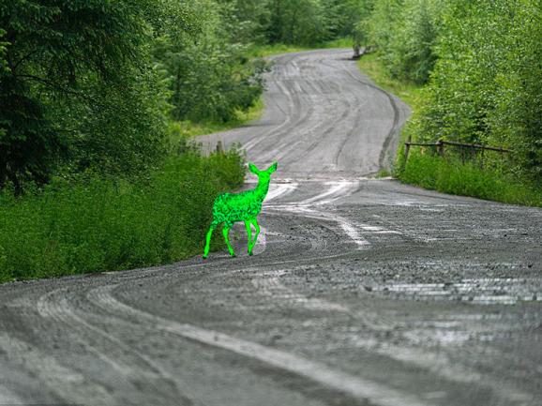
    - Image contrast: Rotate the rotary function button (3) to select this option, and then press the rotary function button (3) to adjust the image contrast between 0 and 9;
    - Display brightness: Rotate the rotary function button (3) to select this option, and then press the rotary function button (3) to adjust the display brightness between 0 and 9;
    - Reticle brightness: Rotate the rotary function button (3) to select this option, and then press the rotary function button (3) to adjust the reticle brightness between 0 and 5;
    - Correction mode: Rotate the rotary function button (3) to select this option, and then press the rotary function button (3) to switch the shutter correction mode;
- Press the power button (2) to return to the home screen.
Note: After the status bar is automatically hidden and the shortcut menu is opened, if there is no operation within 15s, the device will return to the home screen.
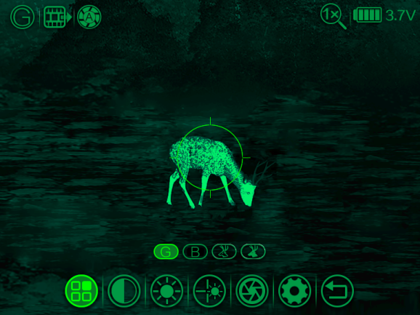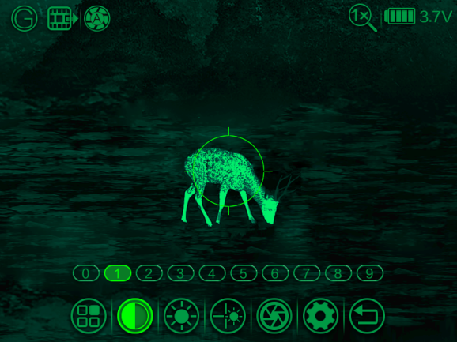
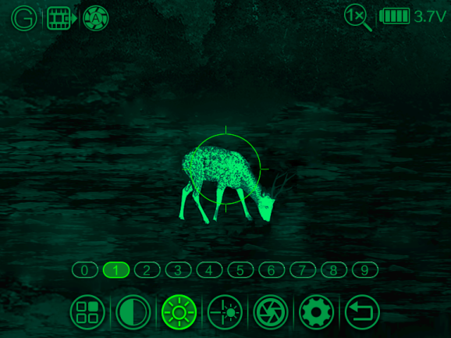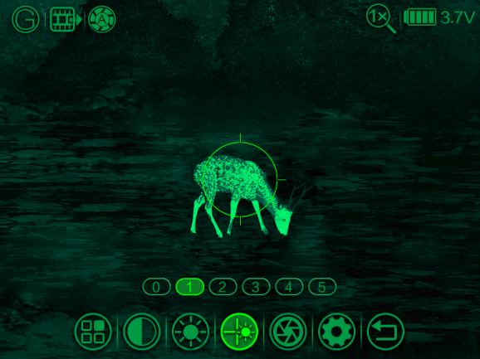
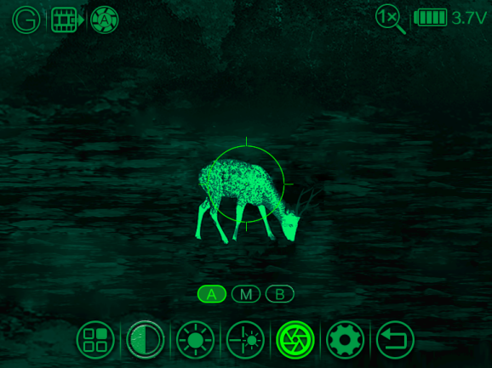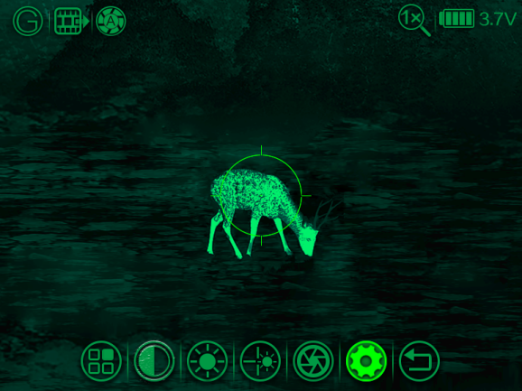

XIII. Advanced Menu:
- On the home screen, press the rotary function button (3) to go to the main menu;
- Rotate the rotary function button (3) to switch between the function options in the main menu, rotate clockwise to move right and anticlockwise to move left;
- Press the rotary function button (3) to modify the parameters of the current option or go to the submenu;
- On all the menu screens, press the power button (2) to go back to the previous menu.
- On some menu screens, the device will automatically return to the home screen without saving the changes when there is no operation within 15s.

Main Menu Features and Descriptions
Zeroing | - Press the rotary function button (3) to enter the menu, and select to enter the advanced menu screen;  - Rotate the rotary function button (3), and select the function option "Zeroing";  - Press the rotary function button (3) to enter the function screen to set them; see Chapter IX "Zeroing" for details.  - Save the settings, and press the power button to exit the function.
Reticle Switch | - Press the rotary function button (3) to enter the menu, and select to enter the advanced menu screen;  - Rotate the rotary function button (3) and select the function option "Reticle Switch";  - Press the rotary function button (3) to enable/disable the reticle display function, and then press the rotary function button (3) to confirm the selection;  - Press the power button (2) to exit the function.  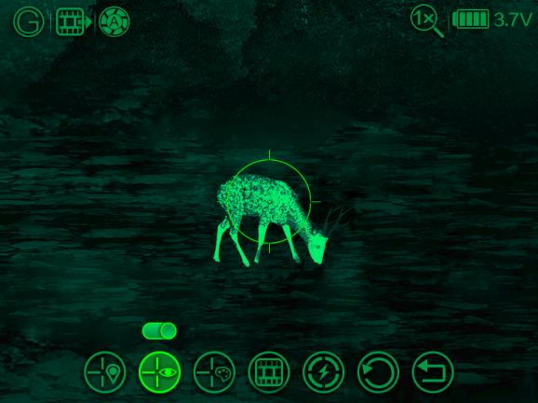
Reticle Color | - Press the rotary function button (3) to enter the menu, and select to enter the advanced menu screen;  - Rotate the rotary function button (3) and select the function option "Reticle Color";  - Press the rotary function button (3) to confirm the current color;  - The reticle color changes accordingly when this function is turned on or off.  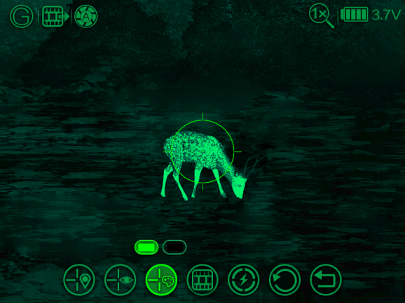
Analog Video | - Press the rotary function button (3) to enter the menu, and select to enter the advanced menu screen;  - Turn the rotary function button (3) to select "Analog Video";  - Press the rotary function button (3) to enter the "Analog Video" enabling page;  - Rotate the rotary function button (3) to set the correct "Analog Video" status;  - After setting, press the rotary function button (3) to return to the previous menu.  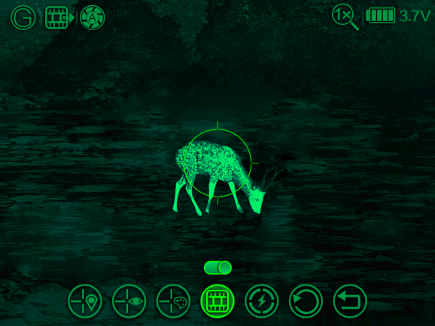
Battery type | - Press the rotary function button (3) to enter the menu, and select to enter the advanced menu screen;  - Rotate the rotary function button (3) to select "Battery Type";  - Press the rotary function button (3) to enter the "Battery Type" screen;  - Rotate the rotary function button (3) to set the correct "Battery Type" status, and press the rotary function button (3) to confirm the selection;  - After setting, press the power button (2) to exit.  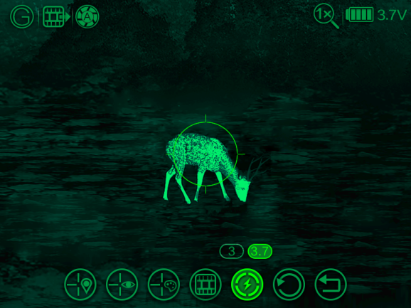
Factory Reset | - Press the rotary function button (3) to enter the menu, and select to enter the advanced menu screen;  - Select "Factory Reset", and press the rotary function button (3) to open the submenu for factory reset;  - Rotate the rotary function button (3) to select Yes or No, with "Yes" for restoring to factory settings or "No" for canceling the operation;  - Press the rotary function button (3) to confirm the option;  - If "Yes" is selected, the scope restores to factory settings automatically;  - If "No" is selected, the operation is canceled and returned to the previous menu.  After the Factory Reset is selected, the following functions are restored to default settings:  - Image mode: Green hot;  - Image contrast: 5  - Display brightness: 5  - Reticle brightness: 5  - Shutter correction mode: Automatic  - Zeroing setting: 0 by default  - Analog video: Off  - Reticle display: On  - Reticle color: White  - Digital zoom: 1.0×;  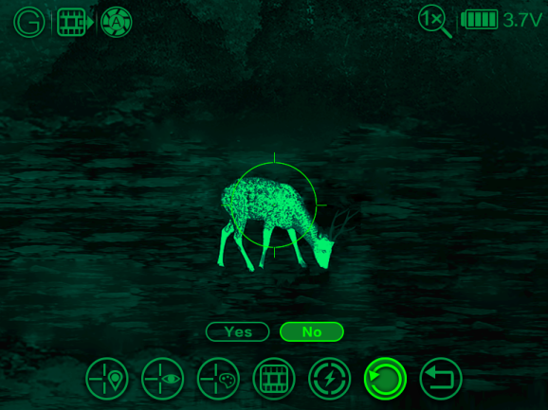

XIV. Technical Inspection
Perform a technical inspection to check the following items each time before you use the device.
- Exterior of the device (no crack on the enclosure).
- Lens and eyepiece (no crack, oil, stain, or other sediments)
- Status of the rechargeable battery (fully charged in advance) and electrical contact (no salinization or oxidation).

XV. Product Maintenance
The maintenance should be carried out at least twice a year and includes the following steps:
- Wipe the surface of metal and plastic parts to clear off dust and dirt by using a cotton cloth. Silicone grease may be used for the cleaning process.
- Clean the electric contact and battery slots on the device using a non-greasy organic solvent.
- Check the glass surface of the eyepiece and lens. If necessary, clear off the dust and sand on the lens (it is perfect to use a non-contact method). Use a specialized wiping tool and solvent to clean the optical surfaces.

XVI. Troubleshooting
The following table lists all problems that are likely to occur during device operation. Check and address problems by referring to this table. If faults not included in this table occur or you cannot fix the fault, return the device to the vendor or supplier for troubleshooting.

Faults | Possible Causes | Solutions
The scope cannot be started. | The battery is out of charge. | Charge the battery.
The device cannot be powered by using an external power supply. | The USB cable is damaged. | Replace the USB cable.
 | The external power supply is insufficient. | If necessary, check the external power supply.
Images are unclear, vertical lines are present, or the background is not even. | Calibration is required. | Calibrate the images as instructed in Section IX of the user manual.
Images are too dark. | The display is not bright enough. | Adjust the display brightness
Icons are clear but images are blurry. | The lens is not focused. | Rotate the lens focus ring to adjust the focus.
 | The inner or outer optical surface of the lens is dusted or iced. | Wipe the outer optical surface by using a soft cotton cloth or leave the scope to dry in a warm and dry environment for more than 4 hours.
The position of the reticle moves after shooting. | The scope or the fixing clamp is not installed firmly. | Check whether the scope is installed firmly.  Ensure that the bullet type and caliber you use are consistent with that used for zeroing.  If you perform zeroing in summer but use the scope in winter (or vice versa), the zeroing point may move slightly.
The scope cannot focus. | Configuration error. | Set the scope according to the contents as specified in the Section of "Power On and Settings".  Check the outer surface of the objective lens and eyepiece, and if necessary, wipe off any dust and frost on it.  In cold weather, a special antifogging coating can be applied (such as those used on eyeglasses or car rearview mirrors).
The observed target disappears. | You are observing the target through the glass. | Observe the target directly without the presence of glass.
The image quality is poor or the detection range shortens. | These problems are likely to occur when you use the device in harsh weather (such as snow, rain, and fog).

