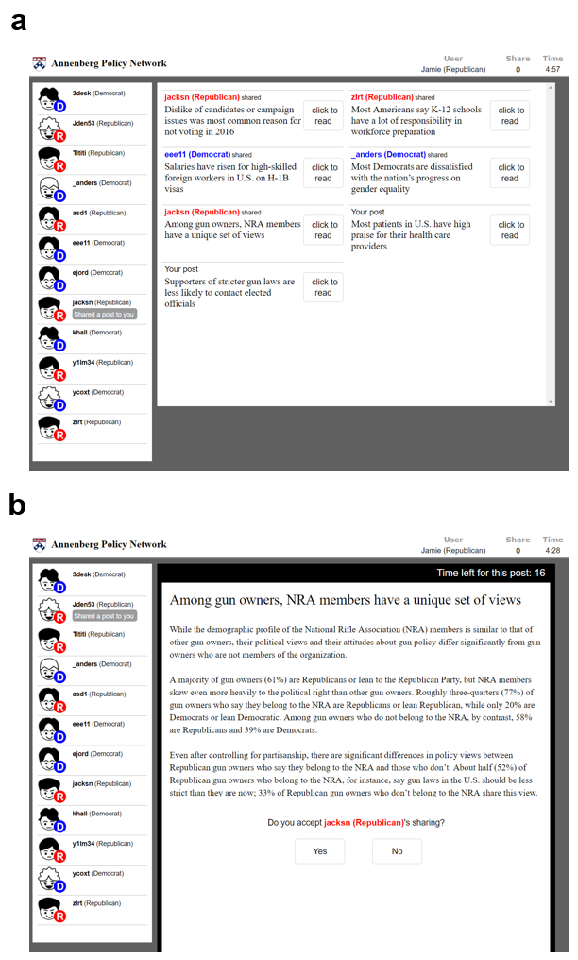
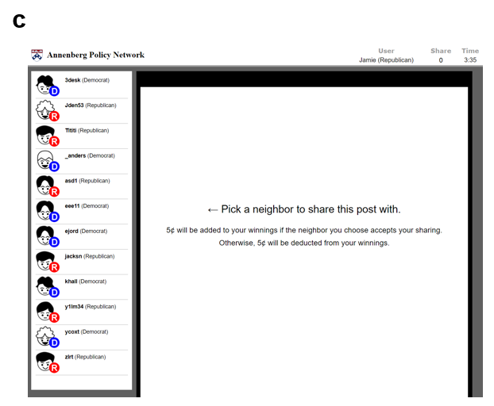
S1 Fig. Example Screenshots of the Experimental Interface. These screenshots illustrate a case of a Republican participant. a. The reception phase with the article list. b. The reception phase after selecting an article. c. The transmission phase.

