Supporting Information

Selection of DNA aptamer and its application as an electrical biosensor for Zika virus detection in human serum

Goeun Park1,†, Myoungro Lee1,†, Jiatong Kang2, Chulwhan Park1, Junhong Min2,*, Taek Lee1,*



Fig. S1 Schematic diagram of SELEX Process

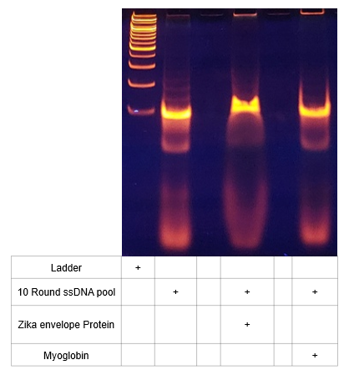

Fig. S2 8% TBE PAGE result of 10 round ssDNA pool

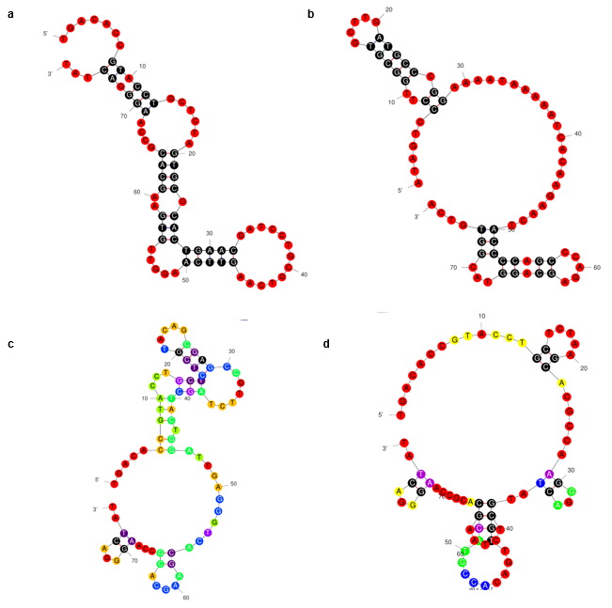  
Fig. S3 Structures of candidate aptamers prepared in Table. 1 **a** Zika -07 aptamer; **b** Zika-09 aptamer; **c** Zika-17 aptamer; **d** Zika-25 aptamer

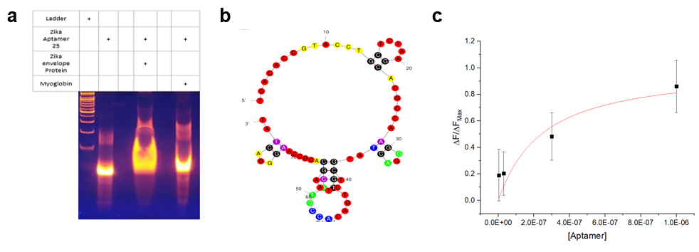

Fig. S4 **a** 8% TBE PAGE result of Zika 25 Aptamer; **b** 2D structure of Zika 25 aptamer base; **c** Binding affinity of Zika aptamer

Fig. S5 AFM image measured with a larger area **a** MXene on SiO2 substrate; **b** MXene, Aptamer on SiO2 substrate; **c** MXene, Aptamer, and Zika virus envelope protein on SiO2 substrate

 Fig. S6 Capacitance trend by AuMGE socket